Basics Of System Administration in Linux

1) Create a new user account and home directory called "Duck"
ANSWER:
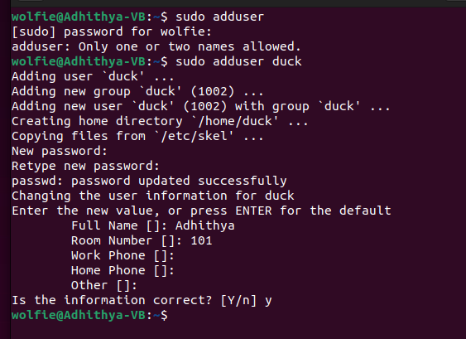

2) Set the user account "Duck's" expirey date as 07 - 01 - 2015
ANSWER:
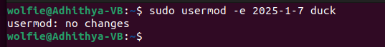

3) find the id of the user account "Duck"
ANSWER:
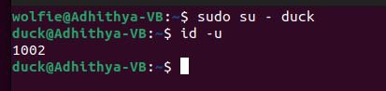

4) Type df and du commands and see the output on your terminal.
ANSWER:
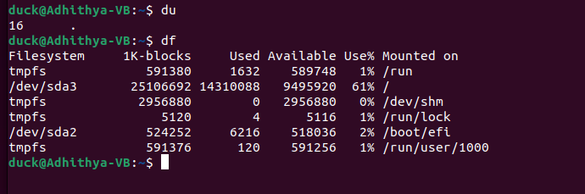

5) Type this command on the terminal and see the output :
du -ch *.txt
ANSWER:
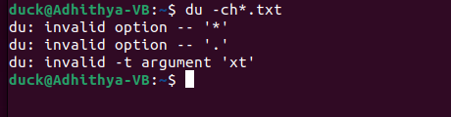

6) Delete the user account "Duck" permanently along with its home folder.
ANSWER:
